Test Bash October25 idea-t workshop

Contents

1 Abstract 1

2 Agenda and timings 2

3 Activities 2

3.1 Choose your group 2

3.2 Round 1 (25 minutes) 2

3.3 Round 2 (25 minutes) 2

3.4 Present 3

4 Rules 3

5 Case Study 1 – choosing a tool 4

5.1 Example research case study 4

6 Case Study 2 – assessing in-house automation 5

6.1 Example research case study 5

7 Case Study 3 – Setting a tooling strategy 6

7.1 Example research case study 6

# Abstract

This workshop gives you a chance to get hands-on and deep dive into the IDEA-T framework of heuristics introduced by Isabel in an earlier TestBash talk. As a workshop attendee, you will gain access to resources that can help enable critical thinking and reflection about tools and the problems they solve. Working together in a round-table, we will see how sometimes heuristics can pinpoint when a tool might actually be the wrong answer to your problems; with the main takeaway of this workshop being that you are empowered to make smarter, evidence-based decisions in your tool design and acquisition efforts. **Level of expertise required for this workshop**: Intermediate.

**Prerequisites:** Useful but not essential to have attended the related talk. Useful to have laptop or something to access the online repository with the heuristics and framework.

**What you’ll learn**

* Heuristics introduced and available to use in design, build and acquisition of test tools.
* Access to a repository with additional material including explanations of the heuristics.
* Evidence to support your decision making whether you supply or use test tools.
* The workshop follows the talk this morning so if you were not there, buddy up with someone who attended the talk.

# Agenda and timings

* 15:55 start - Introduction
* Workshop round 1 (25 mins)
* Break (5 mins)
* Workshop round 2 (25 mins)
* Prepare to present (15 mins)
* Share (round the room, 15/x mins each, 15 mins total)
* Wrap up, finish 17:30

# Activities

## Choose your group

* Choose a case study as a starting point:
  + CS1 you are purchasers of a tool.
  + CS2 you are a team building in-house tools/automation.
  + CS3 you are setting a tooling strategy.

## Round 1 (25 minutes)

* Based on your group’s case study:
* Plan how you will use idea-t – in particular the heuristics – to explore your case study
* Use the QuickStart document to engage with the heuristics
* Use the “Start here” document to guide your planning
  + Improvise around the equivalent research case study as guidance
  + Decide your goal for using idea-t
  + Decide what order you would tackle the themes and heuristics
  + Decide who you would involve (in real life)

## Round 2 (25 minutes)

* Based on your group’s case study:
* Build up one branch of the mind map (use post-its for nodes so you can move them)
* Explore the idea-t framework for prompts for sub questions, explanations and evidence
* Example order: theme -> heuristic -> QR code link -> sub questions and evidence -> attributes

## Present

Prepare your presentation (15 mins)

* “Finish” by:
  + Identifying what you have found out;
  + Identifying decisions you have made;
  + Identifying where there is not agreement across the group;
  + Identifying where you need a deep dive.
* Prepare
  + Make a poster or flipchart or… hold up your mind map?
  + Decide who will present on behalf of your group!
  + Main messages:
    - Starting point.
    - Finish point.
    - What you learnt.

Present your work (be succinct and clear, take turns)

# Rules

* Don’t reject ideas – log everything
* Listen
* Contribute
* Explore
* Speak clearly
* Listen well

# Case Study 1 – choosing a tool

* You are the people who will buy/use the tool ***not*** the people building/supplying the tool.

## Example research case study

* Participants used the idea-t heuristics to help them decide whether to purchase a tool upgrade.
* Participants were the organization’s test domain architect with representatives of the testers who would use the tool.
* Structure they used: Rounds of meetings to:
  + Plan heuristics usage (1 hour meeting).
  + Use heuristics to discuss tool (3-hour meeting).
  + Identify and tackle issues (3 1-hour meetings and follow up).

### Start position and proposition

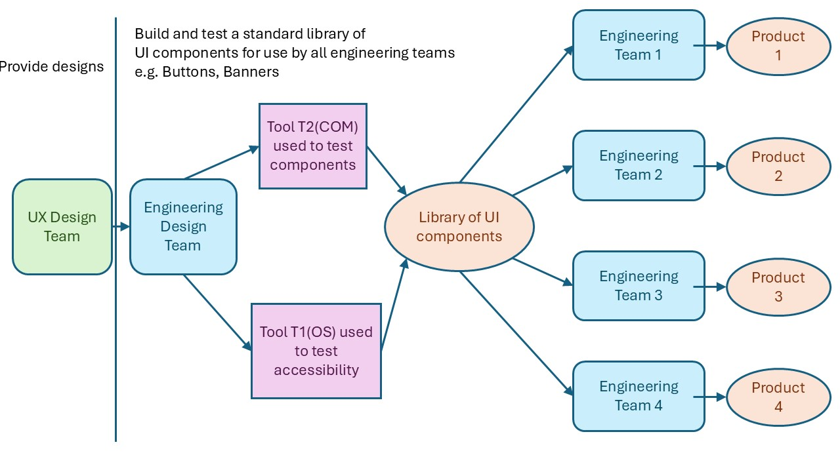

Organizational silo boundary

Organizational silo boundary

Figure Case Study 1: current tooling

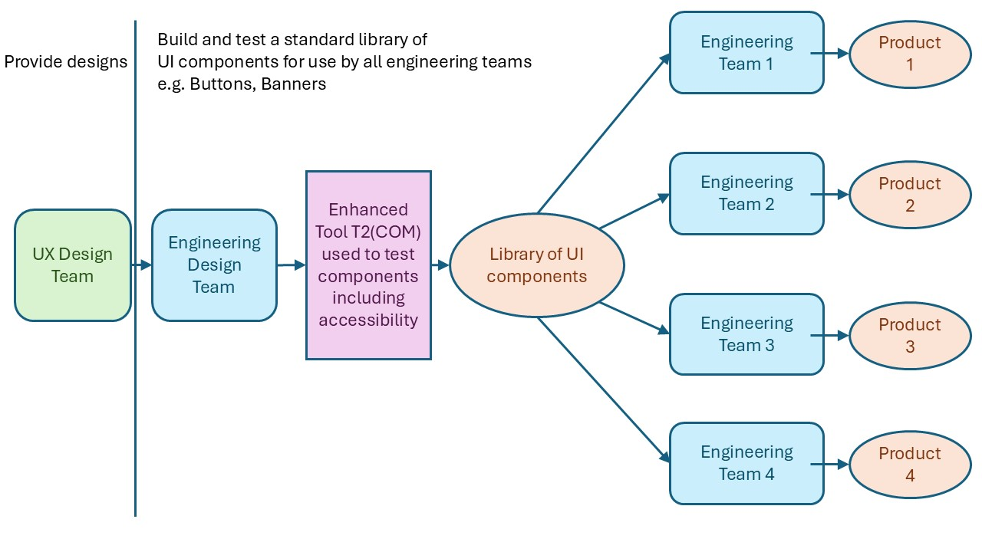

Figure Case Study 1 vendor proposal

# Case Study 2 – assessing in-house automation

* You are the people who build tools and automation for use by others (and perhaps by yourselves as well)

## Example research case study

* Four people took part: Manager plus 3 test automation team leads. They are Building automation for a team of ~500 test engineers to use. Three test suites were reviewed to agree a common understanding of status and next steps.
* Used the heuristics to quickly understand where they had agreement, and where they needed to “deep dive” (3-hour meeting; 1 hour per suite, using the 12 heuristics as “an agenda” 5 minutes per heuristic!). Then workshops were held for deep diving into areas of idea-t.

### Structure and start position

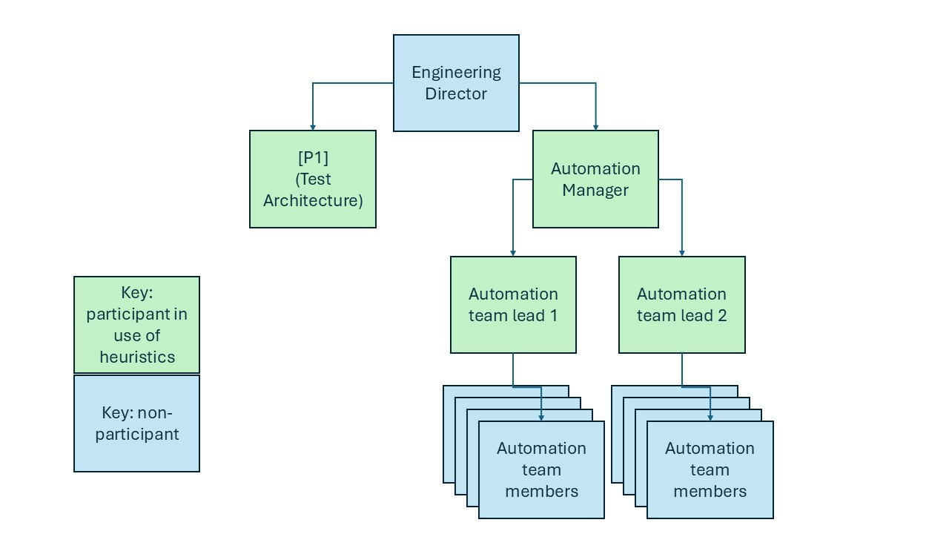

Figure Team structure for the automation teams

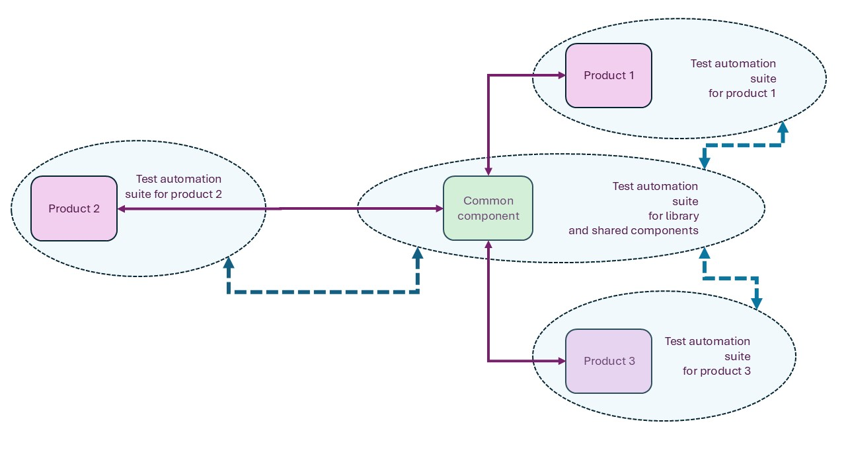

Figure Automation Current Architecture (partial)

# Case Study 3 – Setting a tooling strategy

* You are setting the strategy for tool and automation in your testing organization.

## Example research case study

* Restructure of organization to make all 5000 development engineers responsible for use of the test tools and automation supported by 40 test automation engineers.
* Current structure is 4500 developers separate to the 500 testers, and the testers use the tools provided by the +40 automation engineers.
* The test tooling architect used the heuristics to review their approach to the tooling strategy and their taken for granted assumptions, looking for challenges to bias in their thinking, new ideas.

They built a mind map.

### Current and Desired Position

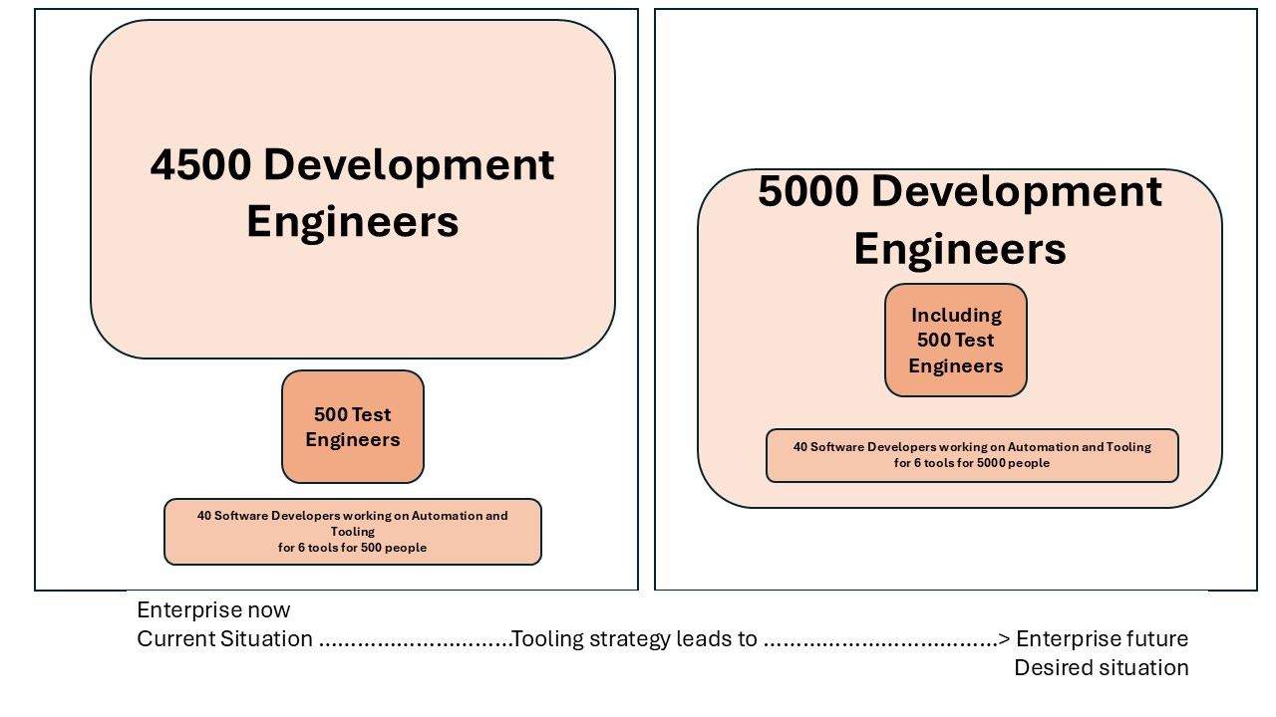

Figure Current and desired situation in this enterprise